1. Download and install [Jenkins](http://jenkins-ci.org/).
2. After the installation, you should be able to visit the Jenkins home page by visiting <http://localhost:8080/>.
3. Download the [Ant](https://ant.apache.org/bindownload.cgi) and extract the folder into local machine (ex: C:\Program Files).
4. Add the **ANT_HOME** in environment variables, ex: C:\Program Files\apache-ant-1.9.4\ and also provide **C:\Program Files\apache-ant-1.9.4\bin** in environment variable of **path**.
5. Configure Jenkins by clicking **Manage Jenkins** on the left sidebar and the go to the **Configure System** page.
6. Setup at least one **JDK installation** and one **Ant installation** as well.

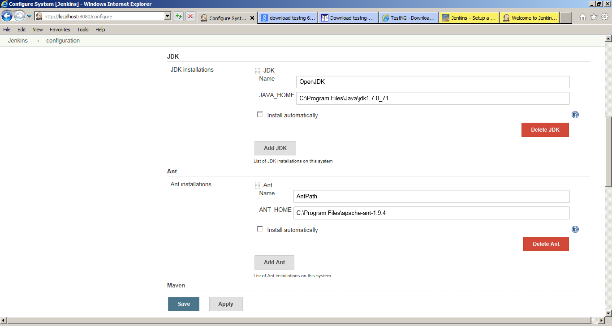  
[jenkins-simple-ant-build-project-3](http://eureka.ykyuen.info/?attachment_id=14679)

1. Now add a new job and call it **CRAFTCI**, select **Build a free-style software project**.  
   [jenkins-simple-ant-build-project-4](http://eureka.ykyuen.info/?attachment_id=14680)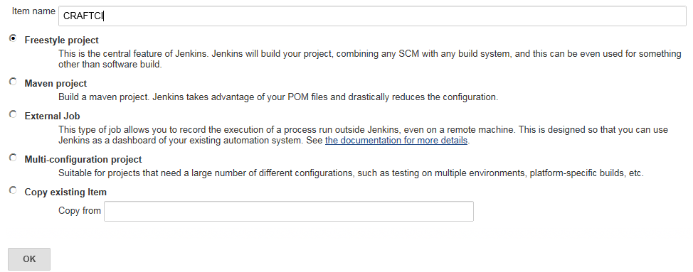
2. After the job is created, you will be on the job configuration page.
3. Add a new **Build step** and select **Invoke Ant**.  
   [jenkins-simple-ant-build-project-6](http://eureka.ykyuen.info/?attachment_id=14682)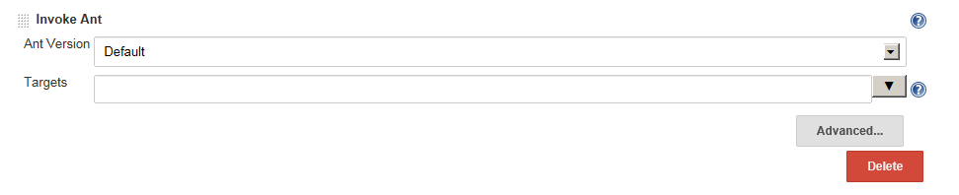
4. Select the Ant version which we have already configured it on the Configure System page.
5. Click on Advanced, you can give the path of build.xml file present under **Miscellaneous** folder.
6. Click on Build Now, this will trigger ant file and trigger Execution , generate reports

